Surrogate Mothers: Womb for Rent

Customer service, tech support...these days we outsource everything to India. So why not pregnancy? Here is a report on the growing number of Indian women willing to carry an American child.
By Abigail Haworth
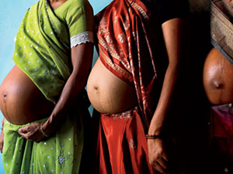
STEPHANIE SINCLAIR
The midday sun is ferociously hot outside the Akanksha Infertility Clinic, a scuffed concrete building in the small Indian city of Anand. Crammed into a single patch of shade by the gate, a stray cow and a family of beggars — caked so uniformly in dung-colored dust they resemble clay models — wait out the noontime heat. Inside, the lobby is jammed with barefoot female patients in circus-bright saris. Nurses in white Indian tunics scuttle among them, hollering out names and brandishing medical files. The air smells faintly of sweat and damp cement. On the walls, blurry photos of babies and newspaper clippings celebrate the clinic's raison d'être: "The Cradle of the World" declares one headline.
In this case, the metaphor is also literal. The Akanksha clinic is at the forefront of India's booming trade in so-called reproductive tourism — foreigners coming to the country for infertility treatments such as in vitro fertilization. The clinic's main draw, however, is its success using local women to have foreigners' babies. Surrogacy costs about $12,000 in India, including all medical expenses and the surrogate's fee. In the U.S., the same procedure can cost up to $70,000.
How surrogacy came to be so popular in the choking backwater of Anand, a dairy community with a population of 150,000 in India's western state of Gujarat, is a long story. The short answer is Dr. Nayna Patel, 47, the clinic's director. A charismatic woman with flowing hair and a toothpaste-commercial smile, Patel single-handedly put Anand on the map when, in 2003, she orchestrated the surrogacy of a local woman who wanted to "lend" her womb to her U.K.-based daughter. The woman gave birth to test-tube twins — her own genetic grandchildren — and the event made headlines worldwide. Afterward, Patel was inundated with requests for surrogacy. She now has 45 surrogate mothers on her books, mostly impoverished women from nearby villages. Twenty-seven of them are currently pregnant, and each will be paid between $5000 and $7000 — the equivalent to upwards of 10 years' salary for rural Indians. More than 50 babies have been born at the clinic in the past three years, half to Westerners or Indians living overseas.
Another example of third-world exploitation? Globalization gone mad? The system certainly lends itself to the criticism that foreign women unwilling or unable to pay high Western fees happily exploit poor women at a 10th of the price it would cost back home. The system also avoids the legal red tape and ill-defined surrogacy laws women face in the U.S. (Not to mention that India, unlike some developing countries, has a fairly advanced medical system and doctors who speak English.) Or is it a mutually beneficial relationship? By some estimates, Indian surrogacy is already a $445-million-a-year business.
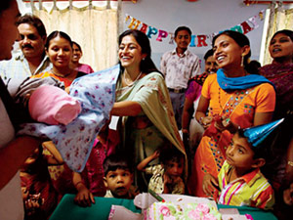
STEPHANIE SINCLAIR
Jessica Ordenes is a petite yoga-school proprietor from New Jersey. Hot, disoriented, jet-lagged, and alone — her husband, David, will join her in a week's time — she is sitting in an empty doctor's office at the Akanksha clinic, sipping fresh coconut juice and waiting for her daily hormone injection. A girlishly pretty woman with dark hair pulled back in a ponytail, Ordenes wears a crisp green shirt and a liberal slick of lip gloss ("to stop my lips from shriveling up in this heat," she explains after numerous reapplications). She has come to Anand because she felt, at age 40, that she was nearly out of time.
Unable to get pregnant but still ovulating, she spent years unsuccessfully trying to arrange for a surrogate in the States to carry her biological child. "I was running out of eggs, running out of hope, and running out of patience with being treated like a number in the U.S. system," she says. "I read about this clinic online — I felt India was my last chance."
Ordenes arrived a few days ago, checked in to the only hotel in town with air conditioning, and arrived within hours at the clinic, where she began having hormone treatments to stimulate her ovaries. In about 10 days, the eggs she produces will be extracted and fertilized with her husband's sperm. Two days after that, if all goes according to plan, some of the resulting embryos will be implanted into local surrogate Najima Vohra, a 30-year-old mother of two. Ordenes knows very little about the woman she hopes will carry her baby. She has met her only once, during a short session with Patel on the first day.
Ordenes is not childless. She had a daughter at age 20 with her first husband, but her uterus became infected after a C-section, and she had to have it removed. Her marriage ended soon after. Three years later, she met David, a pharmaceutical executive and the love of her life. Not being able to have a baby with him tormented her. "I come from a huge family, and I always wanted a house full of kids," she says. Ordenes hoped for at least one child with David "to make our union complete."
The couple, who live in a sprawling house in the suburbs, started to think seriously about surrogacy seven years ago. Ordenes tried local agencies but learned that willing candidates were scarce because New Jersey state law decrees that surrogates cannot receive payment. She found herself languishing on waiting lists and frustrated by potential surrogates who backed out. "It was the most demoralizing experience of my life," she says.
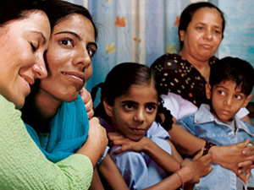
STEPHANIE SINCLAIR
As she sits in the empty doctor's office, a young Indian man wearing a red T-shirt and stonewashed jeans enters the room. Without a word, he proceeds to stick a needle in Ordenes's arm and fill a syringe with her blood. She looks up at him quizzically — she has no idea who he is. After he leaves, she examines the livid red dot left behind on her skin for a second, then shrugs. "So anyway, the years disappeared, and now, as you can see, here I am in India."
The temperature at 9 a.m. the following morning is pushing a brain-melting 107 degrees. Najima Vohra, immaculately dressed in an electric-blue tunic-and-pants set, arrives at the clinic an hour early for her meeting with Ordenes so they can bond a bit more before the procedure begins. It's not the most intimate venue, but Vohra is uncomfortable being seen anywhere else — like most women here, she plans to keep her surrogacy a secret. Vohra is slim, and her long hair is tied back with a plain rubber band. "I couldn't wait to get here," she says through a translator, sitting in a plastic chair in the lobby. "I've been so excited since Dr. Patel chose me to be a surrogate that I haven't been able to sleep."
Vohra says she's not ashamed of being a surrogate, but most locals are very traditional and don't understand. "They think it's dirty — that immoral acts take place to get pregnant," she whispers, explaining their disbelief that she could conceive a child without having sex. "They'd shun my family if they knew." Vohra comes from a village 20 miles outside Anand, but she has temporarily moved to the town with her husband and two children, a 12-year-old daughter and a 7-year-old son, to hide what she is doing. "We told our neighbors we were coming here for work, which is not strictly a lie."
Vohra has no job but helps her husband in his scrap-metal business, for which they earn 50 to 60 rupees ($1.20 to $1.45) a day. If her pregnancy is successful, the $5500 she receives will, as she puts it, "give my children a future."
Growing up, Vohra worked in the wheat fields; she had little education. After her parents married her off at 16, she moved with her husband into a one-room mud house that erodes every year during the monsoon season. She plans to divide her surrogacy windfall three ways: buying a brick house, investing in her husband's business, and paying for her children's education. "My daughter wants to be a teacher," she says. "I'll do anything to give her that opportunity.
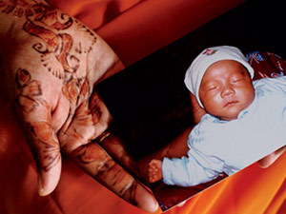
STEPHANIE SINCLAIR
"I'm fit and strong, and I've already given birth twice," she continues, scoffing at the idea of being nervous. And yes, she's mentally prepared to hand over the baby. "It won't even have the same skin color as me, so it won't be hard to think of it as Jessica's." The clinic stipulates that all surrogates must already be mothers so they understand what's involved physically and will be less likely to become emotionally attached to the babies they bear.
Of course, it's impossible for Vohra to know how she will feel after she gives birth — this is the wild card, the reason custody battles sometimes ensue in the U.S. All surrogates at the clinic sign a contract agreeing to hand over the baby — which reassures prospective parents, but also supports arguments that the women, many of whom are illiterate, are being taken advantage of. (In the U.S., only a handful of states regard presigned contracts as legally binding. In others, a surrogate has a small window of time after birth to stake her claim to parental rights.)
Vohra sits in silence for a while and examines her cracked fingernails. "If I do feel sad after the birth, I won't show it," she says eventually. "I can understand how much Jessica wants this baby." In India, she explains, infertility is considered a curse.
Ordenes arrives at exactly 10 a.m., having hired her own car and driver to help navigate the belligerent scrum of auto rickshaws, rusting buses, and camel carts in downtown Anand. She walks over and hugs Vohra, ignoring the custom that discourages lower-caste Indian women from interacting with those outside their group. Vohra smiles.
Ordenes has brought her own interpreter, a female student from the local college recommended by the clinic, since Vohra doesn't speak English. However, when they find an empty ward upstairs and sit on the beds to talk, the women struggle for words. It's as though they both realize the gap between their lives is so vast, there's simply no sensible place to begin.
Ordenes feels her way with some questions about Vohra's kids, then fills her in on her latest ovum count — a topic that consumes foreign patients while they're here, since their sole contribution to the pregnancy is healthy eggs. (Surrogates' own eggs are never used.) Ordenes has produced six eggs so far, but two need extra time to mature. She takes Vohra's hand and squeezes it and promises to look after her during the pregnancy. "You're my angel, you're my angel," she coos and hugs her again. Then Ordenes gets out her camera to take photos to send to her husband.
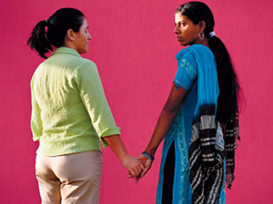
STEPHANIE SINCLAIR
Patel's office is a gloomy, narrow room with a computer at one end and an ultrasound machine behind a fraying living-room curtain at the other. Her enormous desk sits in the center, piled high with papers. The room is constantly packed with nurses, patients, and anyone else who cares to wander in — nobody ever knocks before entering.
Making her rounds of the upstairs ward, where pregnant surrogates have been admitted for monitoring, Patel says the business has taken off beyond anything she imagined. She has about 150 foreign couples on her waiting list, and every week three new women apply to be surrogates. She works 14-hour days and insists she's only involved in surrogacy because there's a genuine need. "I accept patients who have an established infertility problem," she says. "I've had some women ask to do surrogacy because they don't want to give up work for a pregnancy, but I turned them down flat."
All the same, Patel admits there are dangers if the surrogacy business continues to grow in India. "There is little regulation by the Indian Medical Council, the body that oversees such practices," she says. "Rules need to be tighter to ensure women are not exploited."
As a guest speaker at many international infertility conferences, Patel isn't fazed by the foreigners who beat a path to her door — including clients from Taiwan, Japan, the U.S., Europe, and Australia. But she refuses to treat gay couples, revealing her deeply conservative cultural roots. "I get e-mails from gays and lesbians," she says, "some of them very well written — but I don't feel right about helping them." The people she does feel good about helping are the local women — the surrogates — so long as they're not being coerced by their husbands or in-laws eager for a paycheck. "I must be certain it's a woman's own decision," she explains. "If there's any sign of tension or unwillingness, I spot it straightaway." Patel also helps to ensure each woman keeps control over her fee. "For example, if she wants to buy a house, we'll hold her money for her until she's ready. Or if she wants to put it in an account for her children, we'll go with her to the bank to set up the account in her name." The money gives many women their first taste of empowerment.
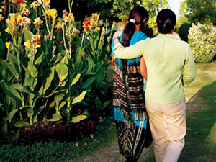
STEPHANIE SINCLAIR
Achieving that financial freedom is hard work. In one of the wards, Sofia Vohra (no relation to Najima), 35, is lying in a room with three beds, an ancient ceiling fan, and wall paint that has bubbled in the heat like a nasty rash. She is about to give birth for the sixth time, to a baby she's carrying for a couple living in the U.S. She has five children of her own, a husband who's a lazy drunk, and a job crushing glass that's used in making (of all things) fortified kite string, for which she earns $25 a month. She became a surrogate for no other reason than to pay for her two daughters' dowries, an illegal — but still widely practiced — Indian marriage ritual.
"I'll be glad when this is over," she says, as Patel places a stethoscope on her ballooning brown stomach. "It's exhausting being pregnant again." Then, in case her complaints are misunderstood, she quickly adds, "This is not exploitation. Crushing glass for 15 hours a day is exploitation. The baby's parents have given me a chance to make good marriages for my daughters. That's a big weight off my mind."
It's lunchtime on Thursday, and the clinic's surrogate mothers crowd into a small room where the staff is throwing a party. Among them is 30-year-old Rubina Mondal, a former bank clerk with long, straight black hair, dressed in a red sari fringed with gold. In February, she gave birth to a healthy boy for a couple from California.
Mondal heard about Patel's clinic on a TV show, and traveled to Anand from her home in the eastern city of Kolkata. Her reason was purely economic: Her 8-year-old son, Raj, has a hole in his heart, and working as a surrogate was the only likely solution to covering his expensive medical care. Patel matched Mondal with Karen, a 33-year-old who works for a mortgage lending company in Los Angeles.
Karen and her husband, Thomas, wanted children, but she had been diagnosed with a uterine tumor at age 16 and knew someone else would eventually have to carry the baby. Mondal conceived on the first try. Over the next eight months, Karen called every week from the States to hear news of her growing child. On top of the surrogacy fee, Karen paid for a spacious two-bedroom apartment in Anand for Mondal's family, hired a cleaner, and sent care packages containing cotton pajamas and panties for Mondal and toys for her two sons.
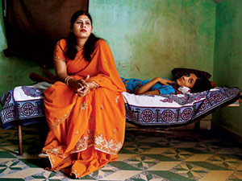
STEPHANIE SINCLAIR
Five weeks before the baby was due, Karen flew to India and moved in with Mondal so they could go through the final weeks together. "Karen became like my sister," says Mondal. Patel delivered the baby boy, Brady, at the clinic.
Like Ordenes, Karen had tried to find a surrogate in the States. "Some of the women were nice, but we just didn't click," she explains. As a Buddhist, Karen thought she'd have an affinity with India's shared beliefs in fate and karma. She also connected with the warmth of Mondal and the clinic. "The people were honest and real," Karen says.
She bristles at those who suggest that she chose India because it was hassle-free. "Some people made it out like we went grocery shopping and came back with a baby," she says. "But being in India was tough — the heat, the mosquitoes, worrying about Rubina and the baby's health. You have to want a baby real bad to deal with this kind of arrangement."
Karen e-mails Mondal photos of Brady every week, and she plans to bring her to the U.S. for her son's first birthday next year. "I want Brady to have a relationship with the woman who carried him for me," she says. Meanwhile, she has embarked on a second surrogacy. Najima Vohra's sister, Razia, is 10 weeks pregnant with a sibling for Brady.
Karen's story gives hope to Ordenes. Ten days after her arrival, she learns that the latest ultrasound has revealed eight healthy eggs — good news, seeing as more eggs mean a greater chance of producing viable embryos to implant in Vohra. Still, the odds are iffy: For a younger couple, the chances of a surrogate conceiving are 30 to 40 percent, but that drops to 15 to 20 percent for someone Ordenes's age.
As excited as she is about the prospect of Vohra's pregnancy, Ordenes isn't sure she can stick around for the embryo transfer — Patel has scheduled it for the following week. "I really want to stay to be with Najima," she says, "but I need to get home because I've arranged to have my basement renovated." She quickly realizes how that sounds and adds a qualifier. "Well, you know, good workmen are very hard to find. And the renovations are for the baby."

