**1.** Read the following extract from ‘German Deserter’s War Experience’ then list words to describe what it was like to be in a trench in World War One.

It was dark, and it rained and rained. From all directions one heard in the darkness the wounded calling, crying, and moaning. The wounded we had with us were likewise moaning and crying. All wanted to have their wounds dressed, but we had no more bandages. We tore off pieces of our dirty shirts and placed the rags on those sickening wounds. Men were dying one after the other. There were no doctors, no bandages; we had nothing whatever. You had to help the wounded and keep the French off at the same time. It was an unbearable, impossible state of things. It rained harder and harder. We were wet to our skins. We fired blindly into the darkness. The rolling fire of rifles increased, then died away, then increased again. We sappers were placed among the infantry. My neighbour gave me a dig in the ribs."

**2.** **Look at diagram A.** Examine it and answer the following questions.

1. What links the front line and support trenches?
2. Why are machine-guns placed just behind the front line?
3. Why is there wire between the front trench and the machine-guns?
4. Look at the barbed wire in No-Man's Land that is at angles to the front trench and also look at the position of the machine-guns. Why is the wire at such an angle?

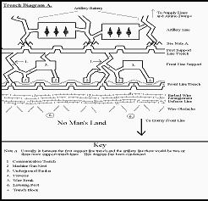

**3. Look at Diagram B**

1. What prevents bullets striking a soldier's chest when he is on the trench board (fire step)?
2. What is the purpose of the sump? What was normally placed over it?
3. Barbed wire entanglements were often 40 yards (36m) from the front trench. Considering the types of weapons used on the Western Front, what would be their main defensive function?

