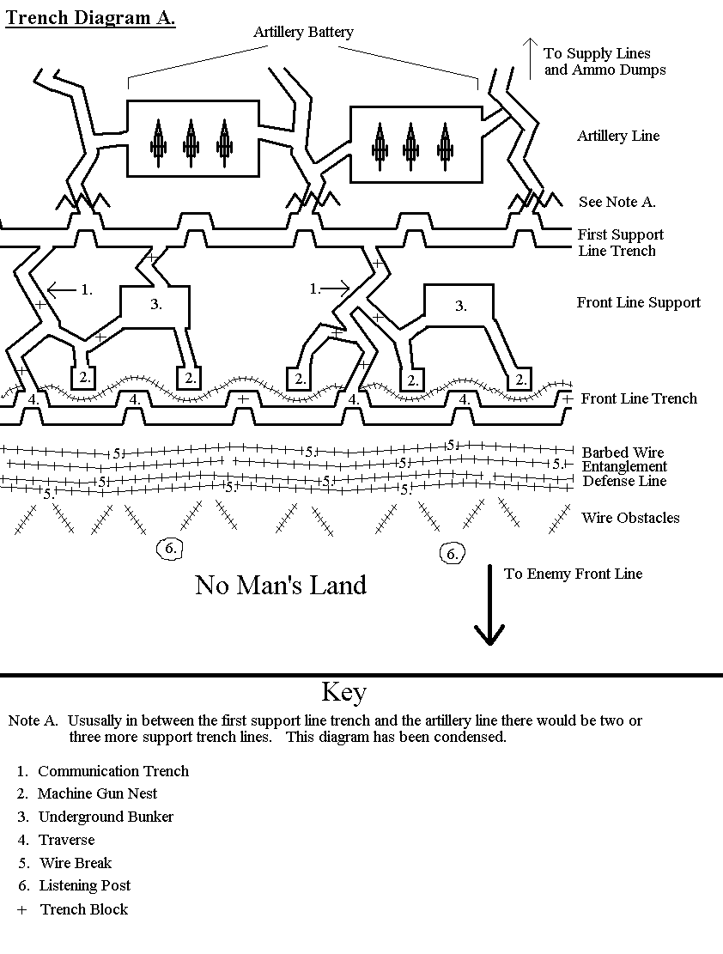

© 2002 [www.historyonthenet.co.uk](http://www.historyonthenet.co.uk)

# Key

1. Communication Trench
2. Machine Gun Nest
3. Underground Bunker
4. Traverse
5. Wire Break
6. Listening Post

+ Trench Block